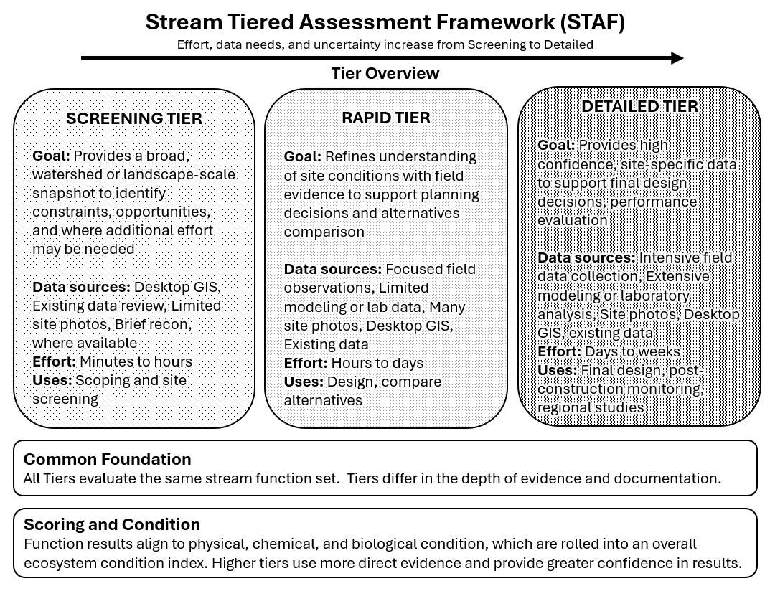
Stream Tiered Assessment Framework (STAF): Fact sheet
The Stream Tiered Assessment Framework (STAF) is a structured, repeatable way to assess stream condition and communicate results. It uses three tiers so the level of effort matches the project need. This supports consistent evaluation across sites while allowing teams to choose the depth of analysis that fits their timeline, budget, and decision needs.
Components
STAF includes three tiers that increase in effort, data needs, and confidence.
- Screening Tier: This tier provides a broad overview using existing information. It is suited for early planning, scoping, and prioritization across many sites. It typically relies on available datasets, mapping, and professional judgement guided by the STAF functions.
- Rapid Tier: This tier adds field data to verify conditions and refine findings at the reach scale. It is suited for conceptual design and alternatives development. This tier is designed to be efficient while producing site-relevant results that are defensible and easy to communicate.
- Detailed Tier: This tier provides the highest resolution and confidence. It can include intensive field data collection, laboratory data, modeling, and specialized methods tailored to project goals. It is suited for final design support, impact evaluation, and monitoring where decisions require higher certainty.
All tiers assess the same set of stream functions. The tiers differ in how each function is evaluated and documented. This foundation improves consistency across projects and makes it easier to compare results across sites, watersheds, and study phases.
STAF uses a scoring approach that summarizes functional results into condition outcomes.
- Each stream function is evaluated using tier-appropriate evidence.
- Function results are summarized to show overall performance and key limitations.
- Results are aligned to physical, chemical, and biological condition to support interpretation and decision-making.
Scoring detail and confidence increase as projects move from Screening to Rapid to Detailed.
Typical uses
STAF is designed to support decisions that occur throughout project planning and implementation.
- Ecosystem restoration planning and feasibility studies. STAF helps identify limiting functions, compare reaches, and support development of alternatives.
- Project prioritization. The Screening and Rapid tiers support ranking and selection across multiple candidate sites.
- Regulatory and planning documentation. STAF provides a consistent structure for reporting and communicating findings.
- Design support and monitoring. The Detailed tier supports design decisions and performance evaluation when higher certainty is required.
Key takeaway
STAF provides a clear tiered pathway, a consistent set of stream functions, and a scoring concept that links functions to physical, chemical, and biological condition. It helps teams scale effort to need, keep evaluations comparable, and communicate results clearly.

